Avonmore Community Playschool

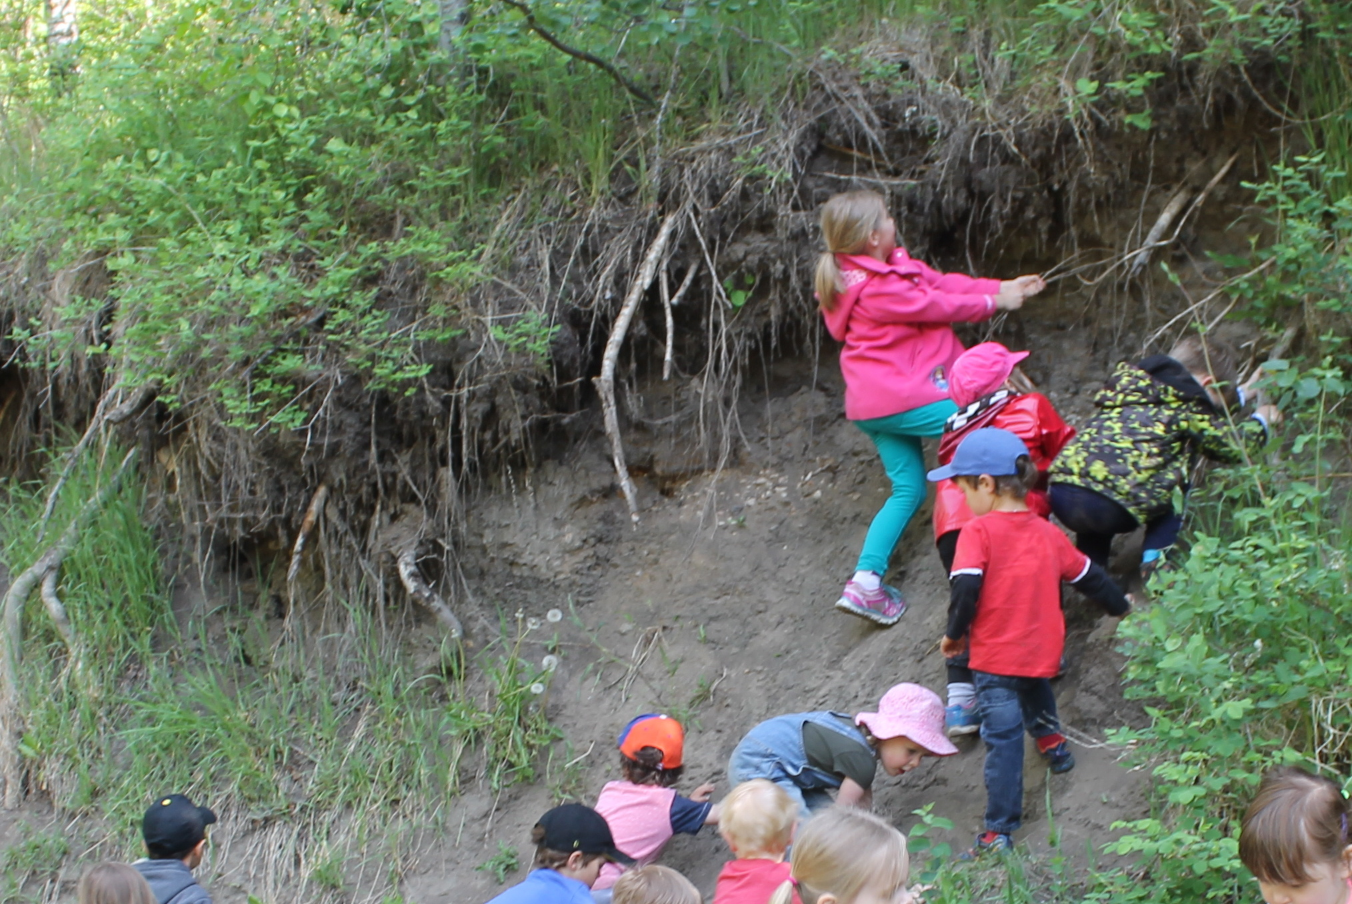

Parent’s Handbook

OUR PHILOSOPHY

Welcome to Avonmore Playschool! Our teachers create a fun and exciting “learning through play” program in a caring and nurturing environment. Our program supports children’s social, emotional, cognitive and physical growth by providing a wide variety of stimulating and developmentally appropriate experiences.

We operate from Monday to Friday mornings 8:45 -11:15 AM.

REGISTRATION FEES AND PAYMENT SCHEDULE POLICIES

Regular School fees are $50.00/month for 2 days, $75.00/month for 3 days a week, $100.00/month for 4 days a week and $120.00 for 5 days a week. There are 3 ways make payment: 10 post-dated monthly cheques or cash at the beginning of each month or monthly e-transfers sent to [ACLPlayDeposits@avonmore.org](mailto:ACLPlayDeposits@avonmore.org), 2 payments, one for each term, September/February) or one lump sum fee at the beginning of the school year.

To avoid problems associated with lack of participation in mandatory volunteering, the playschool requires a Volunteering deposit of an undated check for $200. This will only be cashed in the event that you are unable to fulfill your volunteering duties throughout the year.

The registration fee is $100.00 and is to accompany the completed registration form to hold the child’s spot in the program. This is non refundable.

To comply with licensing regulations, toy cleanings will be scheduled every 4 -6 weeks during regular playschool days (approx. 1 day a month) and parents will no longer be required to do them or put down a deposit, Yay!

Because of the high cost of utilities, building costs, cleaning… the Community League has asked the playschool to help with these costs. So in order to keep our already allocated funding from the Community for the children to buy supplies, go on field trips and have special events; It was voted on by the board that there will be a fee of $100.00 due in 2 payments of $50.00 each in September & February. These payments will go right to the Community League and can be made by cheque or by e-transfer to [ACLDeposits@avonmore.org](mailto:ACLDeposits@avonmore.org)

All parents are required to have Community League Membership. If you are outside the Avonmore Community, another community league membership is acceptable. Memberships will be available at the first parent meeting for $25.00 per family.

There may be bus fees when we take a yellow bus on field trips (usually two a year) as this is not covered by the playschool. Our other fieldtrips we use ETS and are free.

During the year you will periodically see our giving tree grow leaves. If you can help out with an item or 2 off the tree it makes a big difference in helping us provide the children with a few extra fun activities during the year.

PLAYSCHOOL POLICIES

The Avonmore Community League subsidizes our playschool. It pays for the insurance for the children and enables us to obtain a classroom with no rental fees. Naturally, we are given conditions to continue being subsidized.

1. Each child must be a Community League member (not necessarily Avonmore) within the Confederation of Community Leagues.
2. Your child should be at least 3 years of age by December 31st.
3. Children are asked to be toilet trained, but if need be pull ups are allowed, but underwear are recommended. We do not mind helping little ones with accidents when they are learning.
4. Should you choose to withdraw your child from the play school, a written notice must be dated and given one month in advance to ensure that remaining post dated cheques are returned.
5. Registration fees will not be refunded.
6. If you are over 5 minutes late picking up your child after class, you will be charged $5.00, this will only be enforced if it becomes an issue.
7. Playschool will be cancelled in the event of the teacher’s absence when a qualified substitute is not available. If there is more then 2 a year, days will be added on in June.
8. Avonmore Community Playschool reserves the right to refuse a child’s

admittance into the classroom when fees are not paid in full and up to date.

DISCIPLINE POLICY

For minor occurrences in the classroom, the teachers will use positive forms of discipline such as distraction, natural and logical consequences and positive reinforcement. For more serious occurrences, children will be guided to more appropriate behavior by an explanation of the reasons for which being destructive, disruptive or dangerous behavior cannot be permitted. If there are any concerns regarding a child’s behavior, the teachers will discuss this with the parents.

EMERGENCY MEDICAL ATTENTION

Any medical assistance necessary for a child left in the care of the playschool will be sought at the University of Alberta Hospital and be taken by ambulance.

Teachers cannot administer medications, unless it is an epi pen. Parents or emergency contact person will be phoned immediately in the event that emergency medical attention is required.

PARENT RESPONSIBILITIES

1. Children must be accompanied to and from playschool by an adult and when dropping off make sure the child has entered the classroom before leaving. Please inform the teachers if your child will be picked up by a relative or other caregiver.
2. Parents are responsible for undressing and dressing their children in their outerwear each day upon arrival and dismissal time.
3. Parents are required to provide a nutritious snack each day including two or more food items and a drink if your child wishes not to drink water. Please label your child’s snack bag and water bottle. RESTRICTED FOODS WILL BE POSTED AT THE BOARD BY THE WASHROOMS IF THERE IS ANY.
4. If your child would like to celebrate his/her birthday in the classroom, please let the teachers know ahead of time. You may bring in a treat to share with the class and even join us for the morning if you wish.
5. The play school must be advised of any allergies. If emergency treatment needs to be administered for allergic reactions, such treatment must be taught to the teacher and necessary medicine must be provided (i.e. Epi-pen).
6. The playschool must be notified of any change of address and/or phone number.
7. If your child just has a “sniffle” he/she should join us. However, please keep your child at home with the following symptoms: a cold with congestion, listlessness, fever, rash, diarrhea, vomiting, headache or red runny eyes. If your child contracts a communicable disease (e.g. measles, mumps, strep-throat, chicken pox etc.) please inform the teachers.
8. Washable clothes are preferred, as some of the activities tend to get messy. Please send an extra change of clothing.
9. Children must wear running shoes or rubber soled shoes (Velcro closures preferred) while in the classroom for safety reasons.
10. Dress children appropriately for outdoor play everyday. In order to participate in outdoor activities all children must be prepared to go outside.
11. Removable clothing and knapsacks should be clearly marked with the child’s name. The playschool is not responsible for lost or stolen articles.
12. Please leave toys, jewelry and treasured items at home unless it is for show and share.
13. Please let the teachers know of any major events in your child’s life such as a new baby, a move to a new house, etc..
14. Remember to take home your child’s precious crafts and creations daily. You will see this on the clip boards in the coat area downstairs
15. In case of separation, divorce or unsettled situations, the person who has custody of the child must advise the teachers if there is difficulty expected regarding an unlawful party picking up the child. In such cases, the parent must give the teachers the name of the party not allowed to pick up the child. It also must be recorded on the registration form.
16. A playschool meeting is held in the classroom during late summer to go over any information needed, before the start of classes in September.
17. If your child will be absent from class, please notify the teachers that he/she will not be attending. You may leave a TEXT on the teachers cell phone 780- 222-7275.

SCHOOL CLOSURE

In the case of an unforeseen cancellation of a playschool day, you will be contacted with as much notice as possible but it may be the morning of the day to be cancelled. Possible reasons for cancellation include inclement weather, teacher absence when no substitute is available, natural disaster, furnace not working, health or safety issues etc…… If there is more then 2 cancelled days, they will be made up at the end of the school year.

SCHEDULED HOLIDAYS

Avonmore Community Playschool follows the Edmonton Public School Year Calendar.

VOLUNTEERING

Volunteering takes place through out the year to ensure the financial success of our program. We volunteer for the Avonmore Community League and in return they assist us in paying for activities such as field trips, special days and holiday activities as well as any extra or special supplies needed for the classroom.

TEACHERS FINAL THOUGHTS

We look forward to another fun and exciting time here at Avonmore Community Playschool and welcome all the new and past children-families who will be attending with us this year. At Avonmore Community Playschool we provide children with a wide variety of experiences and allow the children to develop at their own speed, while assisting them in their everyday learning. We understand the importance of play and how it is essential to growing minds. We make sure to direct our planning on the children’s interests, creating a more engaging environment for the children to learn and grow! And yes, lots of play!

We are very hands on, which means getting messy is something we do on a regular basis, so please no new clothing unless it is a special event. I say this because if a child comes in wearing an awesome outfit, I will worry all day about keeping them clean (and they always somehow get dirty, usually from the hands of another).